Making Fogcast
Five post writing scaffold upgraded edition
How do you turn imperfect satellite observations and coarse weather forecasts into useful local clear-sky predictions?
Build the series around the decisions that changed the project: inspect the targets, model clear-sky appearance, combine observations with forecasts, and measure what each choice contributes. The central result is that both current satellite information and NBM forecasts help, with their value changing across the ten-hour horizon.

How to use this scaffold
Use the first-person passages as draft material. Complete the focused prompts with run links, counterexamples, and explanations in your own words. Bracketed fields identify missing evidence. Each post should land one conclusion in roughly 800–1,200 words; keep long inventories and extended diagnostics in the repository.
Post | Decision | Main evidence
1 Building the labels | Which observations can supervise the forecast | Shoreline investigation and dataset tradeoffs
2 Modeling clear skies | What physical structure to supply explicitly | Reference basis and residual classifier
3 Designing the forecast | How observations and NBM work together | Input inventory and supervision diagram
4 Testing the inputs | Which changes earn their complexity | A–K comparisons and seed variation
5 Measuring useful skill | Where the forecasts improve on alternatives | Baseline scores and forecast case studies

Evidence already available
The benchmark figures report 5,219 test forecast cases and mean Brier scores across ten lead times. They provide quantitative material for Posts 4 and 5. Split dates, run links, uncertainty estimates, and several implementation choices still need to be recorded before publication.
Working anchors Repository [LINK] • Code release [COMMIT] • Evaluation export [LINK] • Train / validation / test dates [FILL]
Source anchor: Making Fogcast scaffold; clear-reference generator, completed model and embedded forecast benchmark figures. Preserve the figure values as reported until the evaluation export is linked.
POST 1

Before forecasting clouds I had to build the labels
Central question What should the model learn from when no available dataset meets all the requirements?
Working takeaway A suspicious prediction can expose a problem in the training targets. Inspecting those targets changed the modeling task.

Open with the actual need
I’ve always been fascinated by the weather. As a kid, I kept inconsistent weather logs, recording temperature, humidity, and precipitation. I enjoyed observing and tracking it.
Now that I live in San Francisco, fog is a force to be reckoned with. It might be 75°F and sunny in Dogpatch, but 60°F and foggy at Ocean Beach. When planning weekend outings around the city, I’ve therefore become a regular visitor to fog.today. The website displays recent satellite imagery, which you can replay in a 24-hour loop to watch the fog evolve.
I’ve spent a surprising amount of mental energy trying to extrapolate those trends a few hours into the future. Will the fog clear at Crissy Field, or should we move the BBQ to Dolores Park? Will Ocean Beach stay clear through sunset, or will the fog roll back in before then?
That’s what motivated this fog forecasting, or fogcasting, project. I wanted a tool that could provide detailed, sub-kilometer-resolution fog predictions for the hours ahead. I couldn’t find one, so I decided to build it.

Define the event before choosing the data
Although fog motivated the project, I chose to predict clear skies across all cloud layers. Satellite imagery shows cloud structure, but this project does not independently retrieve surface visibility or cloud-base height. The forecast event is clear versus cloudy sky, whether the cloud is low stratus or a higher layer.
The forecast has ten valid times, from one to ten hours after issuance, and is intended to operate day and night. The label generator uses daytime GOES Band 2 imagery at nominal 500 m spacing. At night, visible imagery cannot supply the same information, so the supervision comes from the coarser GOES Clear Sky Mask (CSM).

Tell the shoreline debugging story
I first trained a 2D U-Net classifier using raw GOES B2 observations and solar incidence as inputs, with NASA VIIRS daytime cloud masks as targets. Its predictions frequently marked bay shorelines as cloudy on scenes that looked clear. I initially suspected the model. When I inspected the targets, I found the same shoreline pattern there.
That changed the next experiment. Rather than keep tuning the network against those labels, I used CSM to select training examples for a local B2 classifier. Its first task was to estimate how each pixel should look under clear skies.
Add the actual diagnostic sequence: which VIIRS classes were used, how scenes were aligned, and which checks separated a source-mask artifact from filtering or reprojection behavior. Keep any unresolved cause explicit.
Source anchor: Clear-reference generator, First round and shoreline example; existing scaffold, Post 1 draft prose.
POST 1 EVIDENCE AND ENDING

Show why the target had to change
Data source | Information and coverage | Role in this project
GOES ABI B2 | Nominal 500 m visible reflectance at 0.64 μm; frequent daytime imagery | Fine cloud structure after classification; raw brightness is not a cloud label
GOES CSM | Nominal 2 km cloud mask; frequent observations during day and night | Select reference and classifier samples; provide coarse nighttime targets
VIIRS daytime mask | Nominal 375 m; intermittent overpasses concentrated in the afternoon in the inspected sample | Initial fine targets; shoreline behavior and sparse timing motivated another approach

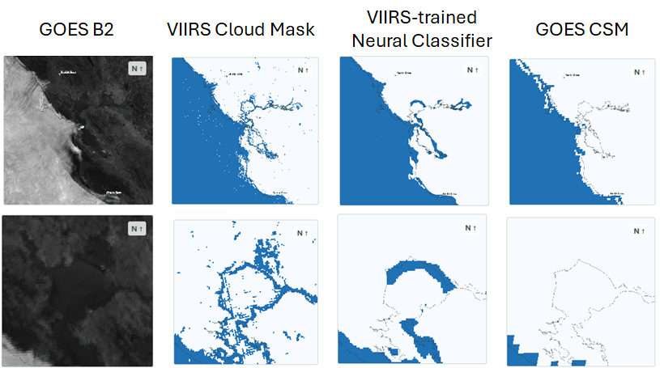
P1 F1 Supplied shoreline comparison. Top row shows the wider scene; bottom row zooms into San Pablo Bay. The VIIRS-derived targets and trained classifier share shoreline patterns absent from the CSM comparison. Confirm timestamps and processing before attributing the pattern to the source product.

End with the changed problem
The next step was to build a clear-sky reference from B2 observations selected using CSM, then classify departures from that reference. This kept the fine daytime structure in B2 while using CSM to guide the fit. It also made the classification rule easier to inspect.
Complete P1 F1 with exact source observation times. The two documents label the example June 14, 2026 at 13:27 and 14:00 PDT. Resolve that difference instead of publishing one inferred time.
Optional asset P1 F2 Plot accepted-label coverage by local hour and season. Use the actual filtered dataset, rather than a nominal satellite revisit rate, to show why VIIRS alone did not cover the task.
Claim boundary Describe the inspected VIIRS-derived masks. These examples do not establish a general ranking of VIIRS and GOES cloud products.
POST 2

Modeling what the satellite should see without clouds
Central question Can an explicit model of clear-sky appearance simplify cloud classification?
Working takeaway Solar geometry, seasonality, and local reflectance explain enough structure to make a simple residual classifier a useful candidate.

Start with the decomposition
A raw B2 image mixes clouds with the appearance of the surface under changing illumination. I modeled the clear-sky appearance first. Subtracting that reference produces a residual that should stay near zero for clear pixels and often becomes positive when clouds increase the observed reflectance.
This decomposition gives me something concrete to inspect. A mistake can come from the expected clear brightness, the residual threshold, or the supervision used to fit them. Interpretability motivated the design; the comparisons still have to establish its accuracy.

Supply physical structure and fit local behavior
For each grid cell, the documented reference uses an 11-term basis with a separate offset for GOES-18. The cosine of solar zenith angle describes incident illumination on a horizontal surface. A solar-hour term lets morning and afternoon differ. Annual sine and cosine terms allow seasonal variation and interactions with illumination.
$R_{clear} = β_{x,y} · φ(c,p,d) + b_{18,x,y} I(GOES 18)$
$φ = [1, c, c^{2}, p, cp, sin(d), cos(d), c sin(d), c cos(d), p sin(d), p cos(d)]$
$c = cos(SZA) p = sin(π(h_{solar} − 12)/12)$
$d = 2π(D_{UTC} − 1)/365.25$
Here hsolar is solar hour, DUTC is fractional UTC day of year, d is annual phase, and the coefficients vary by grid cell. Confirm the implemented phase, leap-year behavior, and solar-hour convention before freezing the equation.

Keep the fit from being dominated by dense days
CSM selects observations treated as clear for fitting the B2 reference. Within each grid cell, a day with many accepted observations receives the same total weight as a day with one. Ridge regularization stabilizes the coefficients except the two intercept terms, and one Huber reweighting pass with δ = 0.03 reduces the influence of large residuals.
The notes report more than 85,000 candidate scenes and more than four million accepted clear pixels. Define whether the latter means unique locations or accepted pixel observations before using it as a dataset-size claim.
Add the exact CSM acceptance rule, coarse-footprint precautions, fit dates, sparse-support fallback, and ridge strength. Explain one case where those choices affected the reference.
Source anchor: Clear-reference generator, Part 1, including the native annual-phase equation.
POST 2 CLASSIFIER

Turn a brightness residual into a cloud score

Fit the separation after removing clear brightness
With the reference in place, I fitted a simple threshold to the residual. The threshold has a global quadratic dependence on solar incidence and a local pixel offset. Shrinking the local offsets toward zero lets local corrections depart from the global rule when the fitting data support them.
$r_{i} = {B2}_{i} − R_{clear,i}$
$τ_{i} = a_{0} + a_{1}c_{i} + a_{2}c_{i}^{2} + Δ_{x,y}$
$s_{i} = σ((r_{i} − τ_{i})/T)$
The score s increases toward cloudy conditions. The source reports a fitted temperature T = 0.013 reflectance units. A clear score reverses the polarity: 1 − s. The binary cutoff and the choice of soft or binary targets for forecast training must match the chosen implementation.

Describe what the fitting objective rewards
$L = \sum_{i}{}w_{i} BCE(y_{i}, s_{i}) + (λ/P) \sum_{j}{}Δ_{j}^{2}$
CSM provides clear/cloudy fitting labels, and weighted binary cross-entropy rewards agreement with them. The penalty limits local offsets, written Δ here to distinguish them from annual phase d. Weights give each pixel and UTC day equal total influence; P is the number of local offsets.
This rule assumes clouds usually raise B2 reflectance relative to the estimated clear scene. Describe the conditions where the assumption becomes weak, such as unusual surface brightness or illumination, using actual failure cases. A sigmoid output alone does not establish probability calibration.
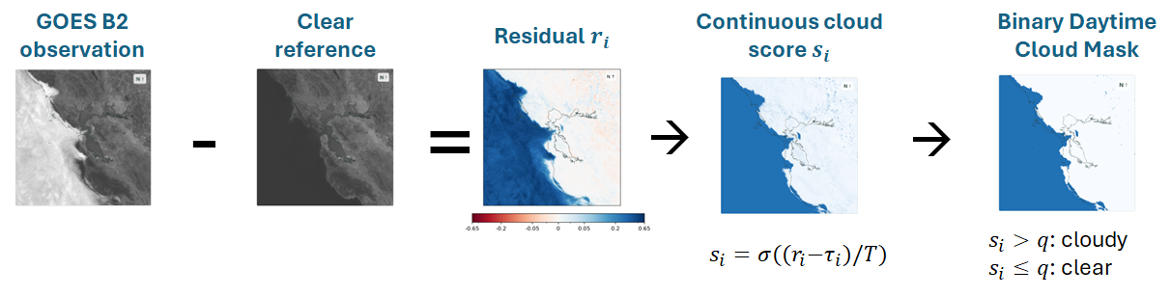
P2 F1 Supplied classifier pipeline. Observation minus clear reference gives a residual; a fitted sigmoid produces a cloud score; a cutoff produces a daytime mask. Confirm the cutoff q and distinguish the cloud score here from the clear score used by the forecast model.
Write the operational label-selection rules: CSM confidence classes, mixed-footprint treatment, invalid B2 handling, accepted solar-angle range, and what happens outside fitted support. These details determine what the classifier has actually learned.
Source anchor: Clear-reference generator, Part 2. The documented threshold has c and c² plus a local offset; check the released code before adding any other term.
POST 2 EVIDENCE AND ENDING

Test the reference where observations are sparse

Use a model comparison to justify the flexibility
The development notes tested the first 3, 5, 7, 9, and 11 terms of the stated basis. The term count is an experimental choice, not evidence that the largest basis is best. Compare the candidates on held-out clear observations and then test whether the selected reference improves classification.
Basis | Terms added at this stage | Held out result and decision
3 | Constant, c, c² | [ERROR / RUN / DECISION]
5 | Morning–afternoon p and cp | [ERROR / RUN / DECISION]
7 | Annual sine and cosine | [ERROR / RUN / DECISION]
9 | Illumination × annual phase | [ERROR / RUN / DECISION]
11 | Morning–afternoon × annual phase | [ERROR / RUN / DECISION]

Core asset P2 F2 Plot observed B2 and fitted reference curves for a well-supported pixel and a sparse-support pixel. Show the observed solar/seasonal range and any extrapolation. Use the same held-out data for every basis.

Keep the reference examples as illustrations
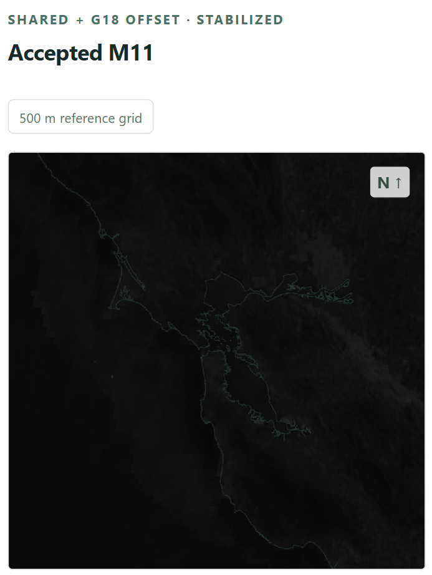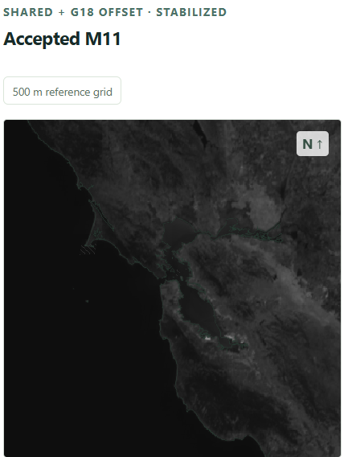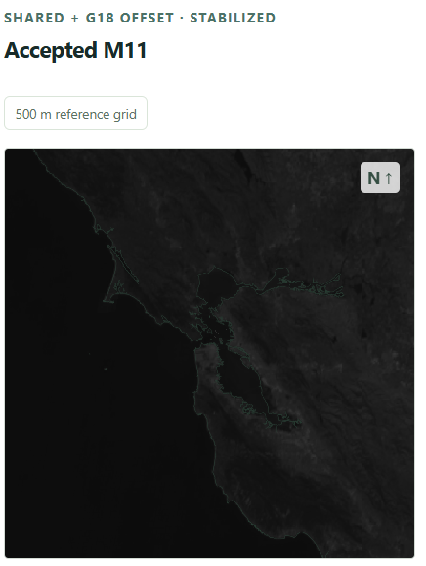
Supplied clear-reference examples for GOES-18: June 14 at 07:30, June 14 at 13:30, and January 6 at 13:30. Confirm year and time zone. These show variation in the reference, not a held-out accuracy result.
Optional asset P2 F3 Compare classification with and without the reference improvement, stratified by solar incidence and fitting support. A smoother-looking reference is insufficient evidence of a better cloud mask.

Close with the supported conclusion
The reference makes local clear-sky brightness explicit and produces frequent daytime labels at the B2 scale. Independent fine-scale accuracy still needs an audit using evidence that did not fit the generator.
Finish with one measured reference improvement, one classifier failure, and the next diagnostic that would distinguish a reference error from a threshold error. [METRIC / COMPARISON / HELD-OUT PERIOD]
POST 3

What the network should learn from a weather forecast
Central question What should come from current observations, external forecasts, and geography?
Working takeaway Current satellite information anchors the initial cloud field. NBM supplies forecast context; geography and solar conditions help connect it to local behavior.

Define the forecast before drawing the network
The documented Model A uses a 200 × 200 km domain with ten hourly outputs at +1 through +10 hours. Its listed 400 × 400 fine grid implies 500 m spacing; the 100 × 100 coarse grid implies 2 km. The earlier scaffold also contains a 1 km and 400 km configuration. Treat these as distinct versions until a code release identifies the one being described.
Input group | Fields in documented Model A | Channels
Fine current observation | B2-derived clear score and its validity mask | 2
Fine geography | Land fraction and elevation | 2
Fine solar context | Solar incidence at issuance | 1
Coarse external forecasts | NBM total cloud cover at issuance and +1…+10 h | 11
Coarse solar context | Solar incidence at +1…+10 h | 10
Coarse current observation | CSM and its validity mask | 2
Coarse seasonal context | Annual sine and cosine at issuance | 2

This inventory totals 5 fine and 25 coarse channels. TCDC describes cloud cover across the atmospheric column; it is not a direct surface-fog or visibility measurement. Record the exact NBM field and product metadata in the repository.

Let the problem motivate the architecture
I chose a residual U-Net because cloud patterns have structure at multiple spatial scales. The encoder gathers broader context as it reduces spatial resolution; the decoder reconstructs a detailed forecast. U-Net skip connections pass spatial detail from the encoder to the decoder. Shortcuts inside residual blocks serve a different role: they make it easier to learn a small change to an existing feature representation.
The architecture combines the fine observations with coarse forecast context. Its spatial inductive bias makes it a reasonable baseline. Shared convolutional filters do not make ocean cells interchangeable: their observations, neighborhoods, and position relative to land can still differ.
Core asset P3 F1: Draw the two input grids, their fusion, the encoder/decoder scales, both kinds of skip connection, and ten outputs from one pinned code release. Put complete tensor wiring in the repository.
Source anchor: Clear-reference generator, Part 3, Model A inventory and architecture motivation.
POST 3 SUPERVISION AND TIMING

Show what is known and what is supervised

Make day and night supervision explicit
Daytime verification uses the fine B2-derived labels. Nighttime verification uses native CSM footprints under low-Sun conditions. The benchmark footnotes define those nighttime cases with solar zenith angle greater than 82° and exclude fine overlap. Confirm whether this is exactly the training partition as well as the evaluation partition.
A fine prediction and a coarse target do not contain the same spatial information. State the actual comparison operator, weighting, and normalization. If the loss pools fine probabilities onto native CSM footprints, draw that pooling. If it uses another operator, document that operator instead. Coarse nighttime supervision cannot by itself validate 500 m cloud structure.
Fill the implemented loss: daytime target encoding [SOFT / BINARY]; daytime validity rule [FILL]; nighttime grid-matching operator [FILL]; night weight [FILL]; reduction and normalization [FILL]; code link [LINK].

Draw the information availability boundary
A future NBM valid time is a legitimate input when that forecast was available at issuance. A future satellite observation belongs to verification. Keep observation time, model initialization time, forecast valid time, and file availability separate when reconstructing historical inputs.
Quantity | What to record | Why it matters
Satellite observations | Observation timestamp, receipt latency, accepted age | Whether the current scene was actually available
NBM forecast | Selected run, valid times, publication latency | Whether the external forecast could have been used
Missing input | Neutral fill, validity mask, fallback or skipped issuance | What the system predicts when data are incomplete
Targets and fitted generators | Fit dates and held-out dates for every stage | Whether future evaluation data influenced the labels

Core asset P3 F2 Use one concrete issuance time to show the eligible satellite frames and NBM run on a timeline, followed by the ten valid times and their later verification observations. Label the time zone and latency assumptions.

End with predictions the next post can test
The input design suggests testable expectations: current satellite information should matter most near issuance, and external forecasts should become more valuable farther ahead. Geography may help the model translate broad cloud forecasts into local patterns. The ablations test those expectations.
Add the issuance cadence, missing-file policy, NBM run-selection rule, and full fitting/training/evaluation dates. Do not infer these from a channel count or a plot title.
Source anchor: Clear-reference generator, embedded benchmark footnotes; existing scaffold, Post 3 availability and supervision prompts.
POST 4

Which inputs actually help
Central question Which plausible changes improve the same forecast task?
Working takeaway The largest losses come from removing observations or NBM. Several plausible additions produce small or mixed changes that require stronger evidence before adding complexity.

Report the experiment before interpreting it
The charts report test mean Brier score across ten equally weighted horizons; lower is better. They show 5,219 forecast cases, validation-selected checkpoints, and raw hourly curves without smoothing. Training used up to 30 epochs with patience 5. Day and night use different supervision families, so compare models within each column rather than treating the columns as the same task.
Model | Change from A | Day | Night
A | Reference model | 0.0913 | 0.1088
B | Remove both satellite inputs and masks | 0.1018 | 0.1249
D | Remove B2 score and mask; retain CSM | 0.0941 | 0.1092
C | Add previous-hour B2 and CSM with masks | 0.0924 | 0.1092
E | Add NBM spread maps and shared mask | 0.0909 | 0.1084
F | Add low-cloud probability maps and masks | 0.0904 | 0.1092
G | Add four-head bottleneck spatial attention | 0.0929 | 0.1114
H | Add seasonal sine/cosine to fine inputs | [NOT REPORTED] | [NOT REPORTED]
I | Expand input to 300 × 300 km | 0.0913 | 0.1068
J | Remove elevation and land fraction | 0.0939 | 0.1117
K | Remove NBM total cloud cover inputs | 0.1240 | 0.1333

Start with the largest effects
Removing both satellite inputs worsened mean Brier by 0.0105 during the day and 0.0161 at night. Retaining CSM while removing B2 did less damage, especially at night. The daytime ordering A, D, B supports the value of fine B2 information in addition to coarse CSM; the nighttime A–D difference is much smaller.
Removing NBM produced the largest daytime penalty in this table: +0.0327, with +0.0245 at night. Its horizon curves diverge more at longer leads. Removing geography also worsened the scores, by 0.0026 and 0.0029. The notes describe a stronger geography effect farther ahead; show that curve before assigning a mechanism.
Source anchor: Clear-reference generator, embedded B/D, C, E, F, G, I, J, and K benchmark figures. Values are the displayed means, not a new evaluation.
POST 4 INTERPRETATION

Give the small and mixed results their proper scope

Make the negative results useful
Adding the previous hour of satellite inputs did not improve the reported aggregate score. That tests one history length and one encoding. It does not show that motion or temporal history is uninformative in general.
NBM spread improved each mean by 0.0004. The low-cloud field improved daytime Brier by 0.0009 and worsened nighttime Brier by 0.0004. The attention model was worse in both columns. These are mixed or small results, and the figures provide no uncertainty intervals for the differences. Describe the outcomes numerically before using words such as “useful” or “significant.”
Addition | Original expectation | Supported interpretation
One-hour history | A second scene could expose motion | No aggregate benefit in this encoding and training setup
NBM spread | Forecast uncertainty could guide correction | Small improvement in reported means; repeatability unresolved
Low-cloud probability | Different cloud layers could evolve differently | Small daytime gain and nighttime loss; no consistent gain
Spatial attention | Nonlocal communication could help | No improvement in this tested configuration

Use the existing seed runs to set the scale
Model A seed | Day mean Brier | Night mean Brier | Selected epoch
42 | 0.0913 | 0.1088 | 30
43 | 0.0925 | 0.1096 | 30
44 | 0.0925 | 0.1093 | 29

The displayed range across these A runs is 0.0012 during the day and 0.0008 at night. Several proposed gains are smaller than those ranges. That motivates matched repeats; it is not a confidence interval or a significance test. The source heading mentions a three-seed blend, but the figures show individual seeds. No ensemble score is established.
Core asset P4 F1 Plot score differences from A by horizon for B, D, J, and K. Use matched support and a clear sign convention. Put smaller additions in a separate panel so they remain readable.
Complete the comparison record: split dates, run/config links, per-horizon counts, compute budget, and repeated-run protocol. Decide keep / remove / defer using both measured gain and operational cost.
Source anchor: Clear-reference generator, addition experiments and the two figures under Blend of 3 seeds for Model A.
POST 4 SPATIAL CONTEXT

Explain what the larger input domain tested

Separate extra context from boundary effects
Model I expands the input from 200 × 200 km to 300 × 300 km, adding 50 km on each side. The stated motivation is to reduce the influence of domain boundaries and expose more surrounding weather. The reported mean is unchanged to four decimals by day and improves from 0.1088 to 0.1068 at night.
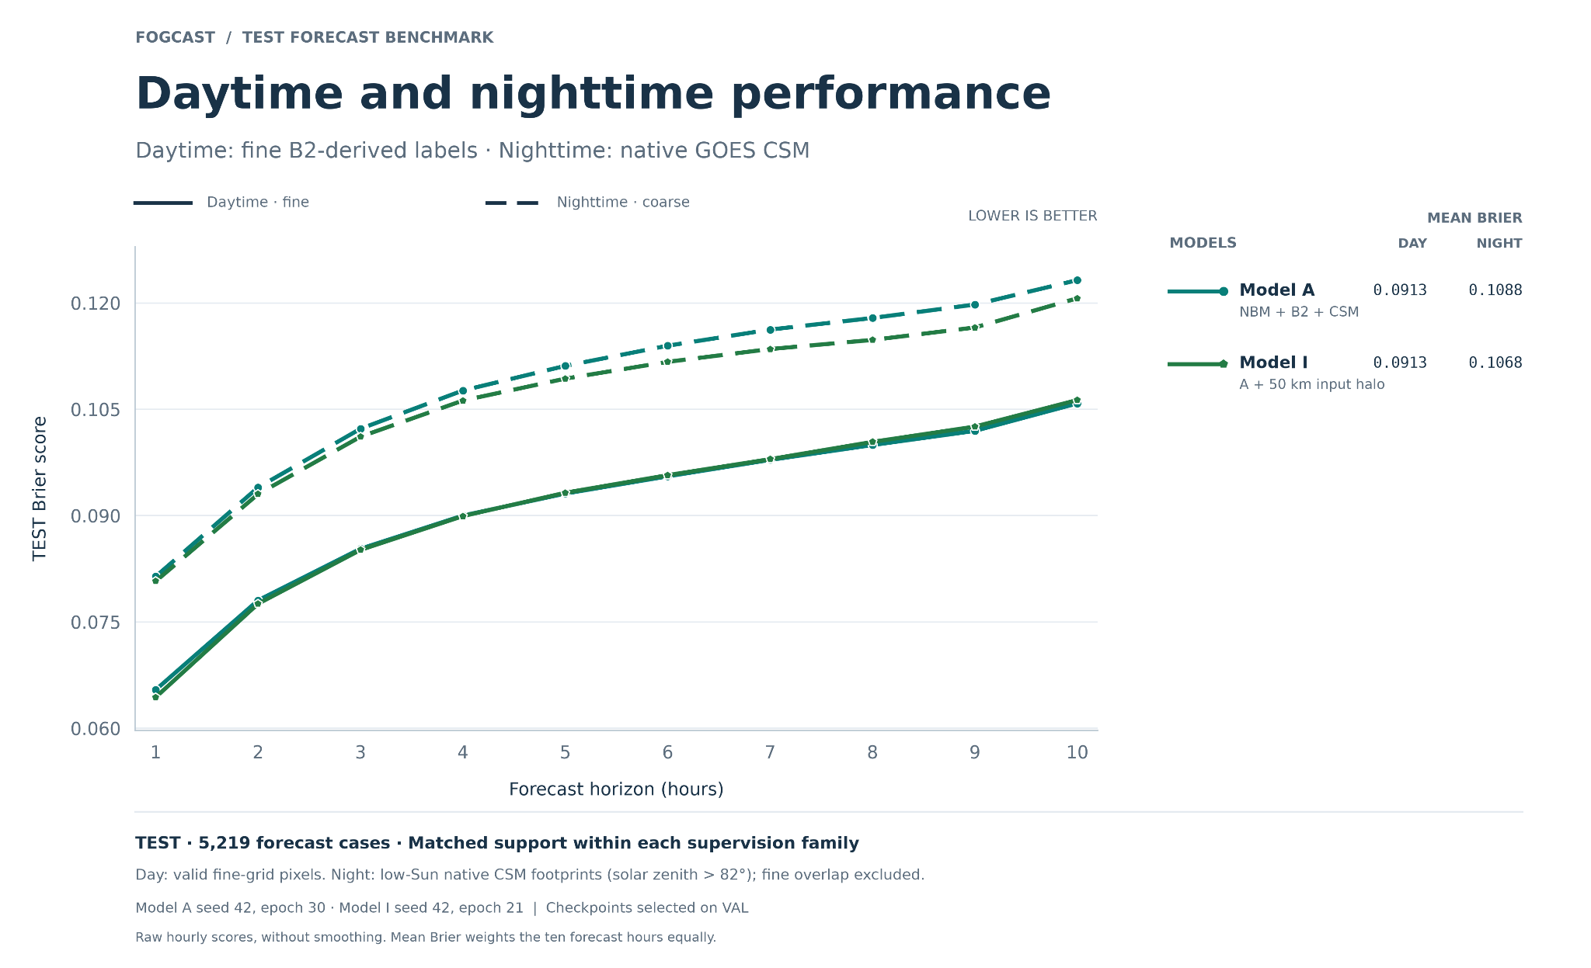
P4 F2 Supplied Model I comparison. The chart reports Model A and the 50 km input halo on matched support within each supervision family. Day and night use different target scales. Model I was selected at epoch 21; Model A at epoch 30.
The notes estimate about 90 km of convolutional reach, but do not settle whether that means full width or one-sided reach. If it is one-sided, a 50 km halo does not eliminate all boundary influence. A larger input can also help by adding upstream context, so an aggregate score change alone cannot identify padding as the cause.
Optional diagnostic: Plot error against distance from the original domain boundary, on the same central scoring region. Record the actual training-loss crop, receptive-field definition, padding, and input domain. Compare with an equal-compute control if making a claim about efficiency.

Bridge to absolute forecast skill
An ablation says which parts contribute relative to Model A. The practical question is whether the complete forecast improves on persistence, climatology, and the external weather forecast. Those comparisons belong in the final post.
POST 5

Does Fogcast forecast better or just draw sharper maps
Central question Where does the model add predictive skill, and what does the evaluation actually verify?
Working takeaway Model A improves the reported mean Brier score over the supplied baselines. Fine-scale accuracy remains constrained by the supervision used to assess it.

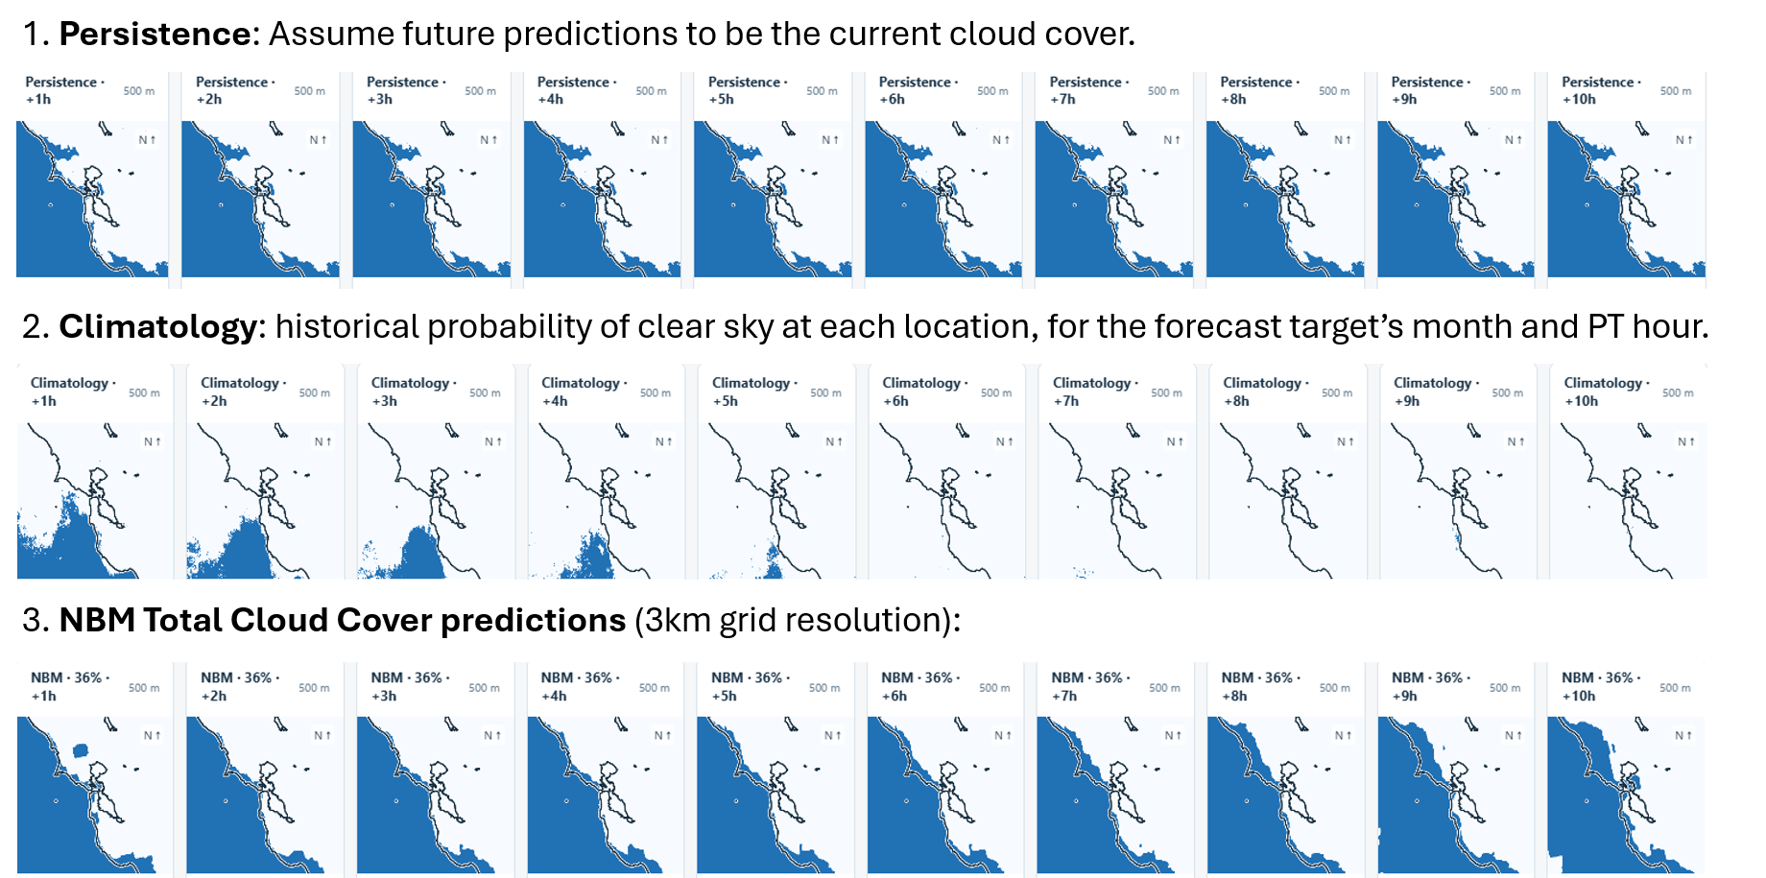
Figure. Representative set of baseline fields (here, shown thresholded). Data timestamp: 2023-05-14 at 9:00AM PDT.

Lead with the baseline comparison
Forecast | Day mean Brier | Night mean Brier
Model A | 0.0913 | 0.1088
Direct NBM | 0.1156 | 0.1332
Persistence | 0.2303 | 0.2084
Climatology | 0.2046 | 0.2103

Against direct NBM, Model A reduces the displayed mean Brier score by about 21.0% during the day and 18.3% at night. These are relative score reductions, calculated as (baseline − Model A) / baseline. They are not percentage-point increases in accuracy.
The benchmark legends define direct NBM as continuous 1 − cloud cover, persistence as the current state held forward, and climatology as estimated from training data only. Confirm the precise initialization, temporal climatology, regridding, masks, and product/run-selection rules in the evaluation code.

Show the horizon curves before the case studies
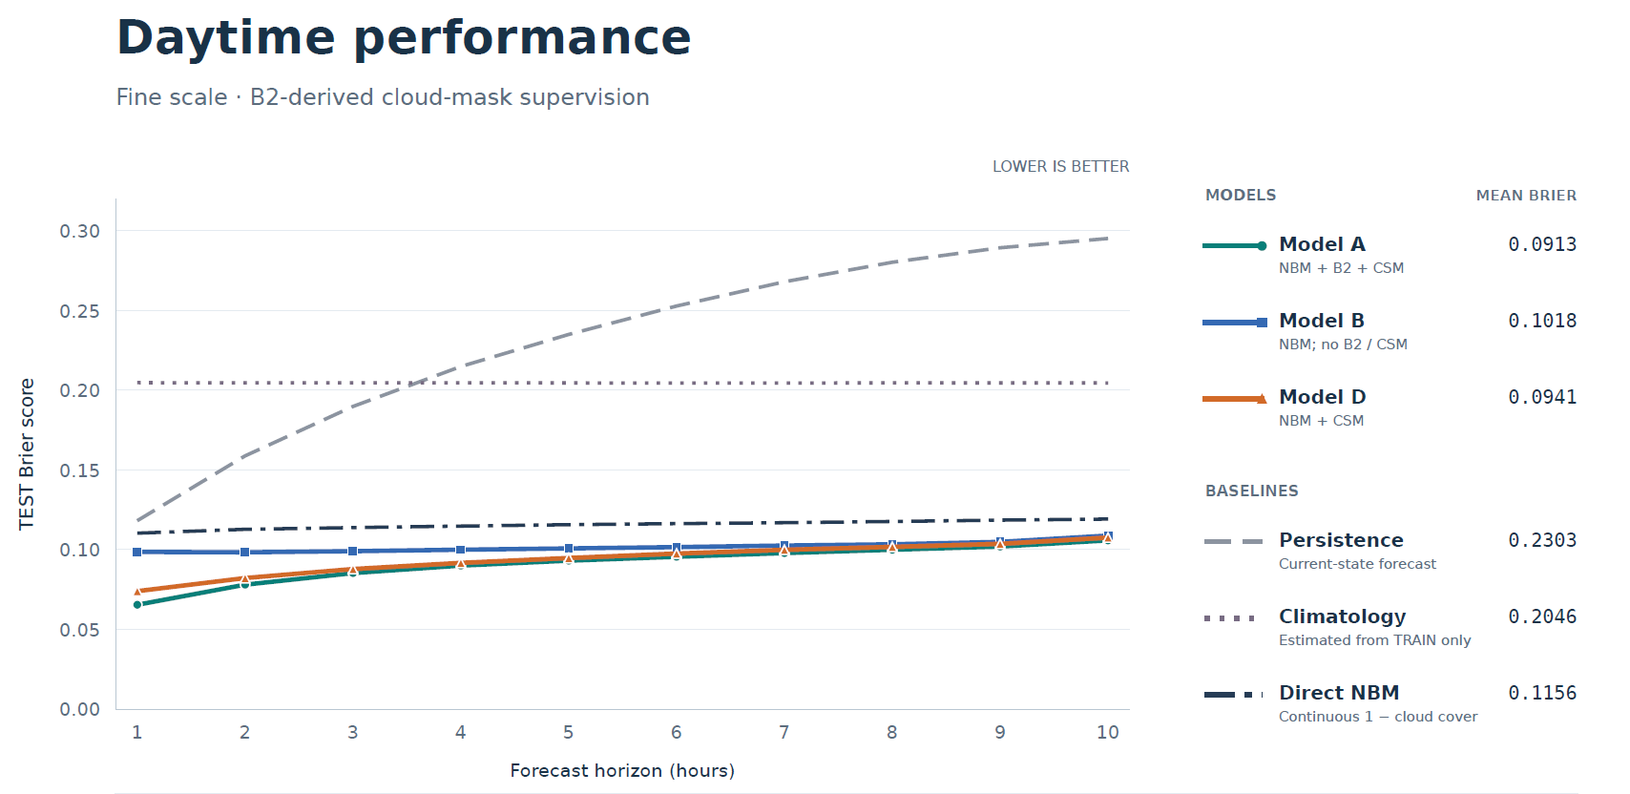
P5 F1a Supplied daytime benchmark with satellite ablations and baselines. Fine verification uses B2-derived supervision. Confirm complete case and support metadata in the evaluation export.
Important baseline distinction Model B removes satellite inputs from a trained network while retaining NBM and contextual inputs. It is not the raw NBM baseline.
Source anchor: Clear-reference generator, forecast benchmark charts. Relative reductions use displayed rounded values.
POST 5 LIMITS AND NEXT EVIDENCE

Show what a better score means in practice
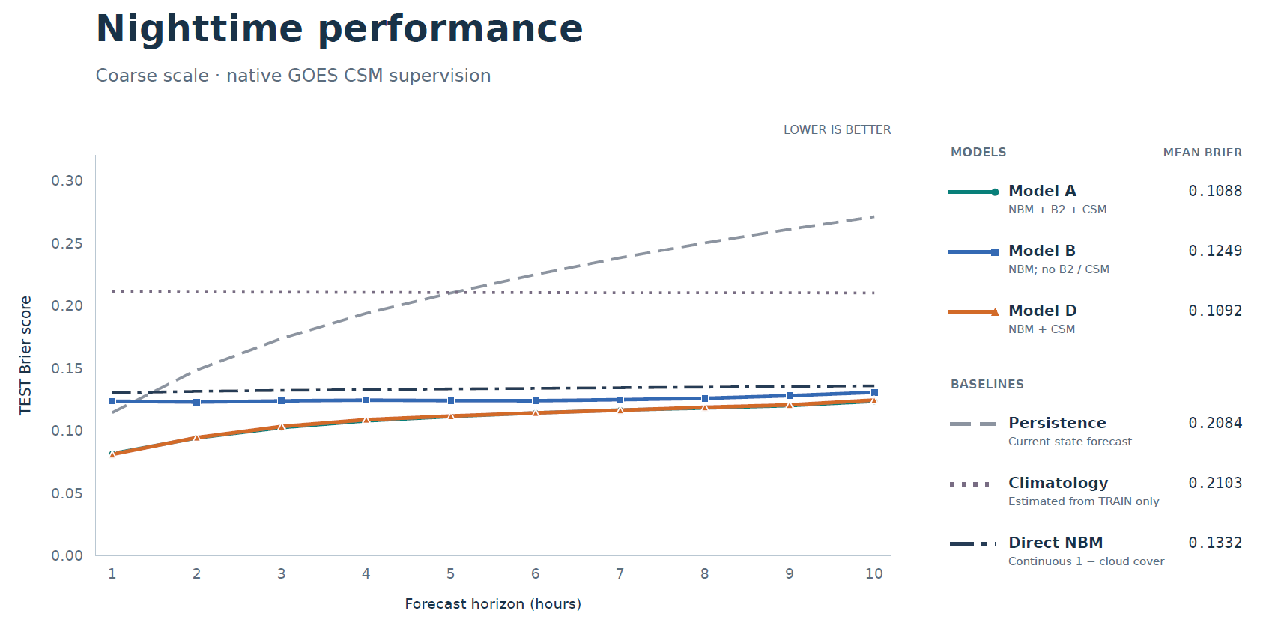
P5 F1b Supplied nighttime benchmark. Verification is coarse native CSM under low-Sun conditions. This supports a nighttime forecast comparison at that scale; it does not independently verify fine cloud boundaries.

Separate target agreement from independent validation
The daytime labels come from the B2 classifier, whose fit uses CSM. Nighttime verification uses CSM directly. These benchmarks establish agreement with the stated supervision. They do not independently establish that a 500 m output resolves clouds correctly, and nominal grid spacing is not the same as demonstrated effective resolution.
NBM cloud fraction and a pixel-level clear/cloud score are also different quantities. Explain why the chosen score is meaningful for the use case, then include a comparison at a common spatial support if claiming general superiority over the external product.

Choose cases that answer a question
Core asset P5 F2 Build a synchronized contact sheet or animation with Model A, NBM, persistence, and verification at identical valid times. Include a clearing event, a fog return or advance, and a failure. State the case-selection rule, initialization, time zone, extent, and color scale.
Case record: [DATE / SELECTION RULE / WHAT CHANGED / WHICH METHOD GOT THE TIMING RIGHT / VERIFICATION SOURCE / FAILURE / NEXT CHECK]. Use a static fallback for an animation.
Optional asset P5 F3 If calling outputs probabilities, add a reliability diagram with bin counts and a separate calibration/evaluation split. A proper score against soft derived targets alone does not establish calibration for an independently observed binary event.

End with the measured result and its main limit
On the reported test benchmark, Model A improves mean Brier over NBM, persistence, and climatology. The next step is to show where that gain changes a local forecast decision, while independently auditing the fine detail and documenting the conditions where the system fails.
Close with one actual forecast episode, its score or timing error, and the next experiment justified by that failure. Link the reproducible example. [CASE / LIMITATION / NEXT TEST / REPOSITORY LINK]
SHARED WORKBOOK

Capture the evidence while you work

Experiment and decision record
Field | Record
Question and expectation | [What did I expect, and why?]
Change and controls | [What changed; matched cases; seeds; training budget; possible confounds]
Reproducibility | [Run IDs; code commit; configs; data versions; dates; evaluation command]
Result | [Metric; direction; denominator; horizon; uncertainty; artifact link]
Interpretation and decision | [What follows; what remains open; keep / remove / defer; next test]

Figure and animation record
Identity Asset ID and post [FILL] • Status [PLANNED / READY] • Main question [FILL]
Data slice and selection rule [FILL]
Run IDs and generation script [LINK]
Editable source and export [LINKS]
Caption [Finding, comparison, and limitation]
Accessibility text [What a reader needs to know without the image]

Unexpected result note
On [SCENE / RUN], I noticed [OBSERVATION]. I first suspected [EXPLANATION]. I checked [DISCRIMINATING TEST]. The result was [EVIDENCE]. I changed [DECISION]. What remains unresolved is [QUESTION].

Visual conventions
Keep one cloud/clear polarity and consistent scales across figures. Distinguish observation, derived target, and prediction. Label issuance and valid times with time zones. State native and working grid spacing, masks, units, and denominators where they change the interpretation. Use the same extent when comparing methods.

Next writing session
Draft Posts 1–3 from the supplied prose and technical material. Export the benchmark data for Posts 4–5, link the saved runs, and resolve the specification questions on the next page before finalizing diagrams.
BEFORE PUBLICATION

Resolve the model version and support each claim
Item | What to resolve | Decision or evidence
Grid and domain | Model A tensors imply 500 m over 200 km; scaffold also lists 1 km and a 400 km input. Its x bounds do not center input and output on the same easting. | [RELEASE / CONFIG]
Larger input | Model I figure uses 300 km with a 50 km halo. Keep any 400 km configuration separate. | [LOSS CROP / SCORE REGION]
Reference phase | Source gives 365.25 denominator; confirm fractional UTC day, solar hour, leap years, and any clipping. | [CODE / EQUATION]
Sample support | Define 85,000 candidate scenes and four million accepted pixels; document CSM selection and mixed footprints. | [DATA COUNTS / FILTERS]
Classifier contract | Confirm threshold terms, score polarity, binary cutoff, T, and soft versus binary forecast targets. | [CODE / RUN]
Day and night loss | Confirm training partition, native footprint operator, masks, weighting, and normalization. | [LOSS CODE]
Evaluation independence | Record fit dates for reference, classifier, climatology, and forecast model; protect the final test from selection. | [SPLITS / AUDIT]
Shoreline scene | Resolve 13:27 versus 14:00 PDT; distinguish source classes from processed masks. | [EXACT TIMESTAMPS]
Ablations and seeds | H has no result; blend has no reported score. Quantify uncertainty before claiming significance. | [RUN EXPORT / REPEATS]
NBM extra field | Confirm Model F event definition below 3,000 ft and product metadata; verify NBM run availability. | [FIELD / LATENCY]

Publication and repository handoff
Each main claim should point to a saved result or an identified observation. Quantitative claims need a metric, comparison, horizon, and evaluated population. Keep null conclusions within the tested setup. Replace bracketed fields with evidence or remove the unsupported claim.
Provide a README with the problem, one end-to-end figure, current result, and main limitation. Link a small reproducible example, pinned configs, data provenance, evaluation commands, and figure scripts. Remove author prompts from the published posts.
Source anchor: Making Fogcast scaffold and Fogcast clear-reference generator. Link each final figure to its generation script and saved evaluation.

